**Experiment Name:** Introduction to Oscilloscope.

**Objective:**

The object of this experiment is to learn how to use the oscilloscope by measuring the periods and amplitudes of various waveforms as well as analyzing a sound wave.

**Theory:**

The oscilloscope is an electronic instrument widely used in making electronic measurements. The most noteworthy attribute of an (ideal) oscilloscope is that it does not affect the quantity being measured.

**Equipment:**

1. 1 digital Oscilloscope.
2. 1 function generator.
3. BNC to 2 alligator clips cable.

**Maximum Input Voltage:­**

The maximum input voltage the probe is safely rated for. Most probes are either Category II (150V AC) or Category III (300V AC). These values should be considered absolute maximums and should never be exceeded. There is significant risk to personal injury if these levels are exceeded.

**Function Generator:**

Function generator is a way to select a waveform type: sine, square, and triangle are most common, but some will give ramps, pulses, “noise”, or allow you to program a particular arbitrary shape. At least two outputs. The “main” output, which is where you find the desired waveform, typically has a maximum voltage of 20 volts peak-to-peak, or ±10 volts range. The most common output impedance of the main output is 50 ohms, although lower output impedances can sometimes be found. A second output, sometimes called “sync”, “aux” or “TTL” produces a square wave with standard 0 and 5 volt digital signal levels. It is used for synchronizing another device (such as an oscilloscope) to the possibly variable main output signal.

**Types of Oscilloscope:**

There are two types of oscilloscopes, they are…

1. Analog Oscilloscope
2. Digital Oscilloscope

**What is an oscilloscope used for:**

An oscilloscope is a laboratory instrument commonly used to display analyze the wave form of electronic signals. In effect, the device draws a graph of the instantaneous signal voltage as a function of time. An oscilloscope usually has two or four channels and one can see one to four signals simultaneously on its screen. In order to use these instrument, we have to make sure that are reset to the factory setting.

**What is an oscilloscope use to measure:**

Every oscilloscope display should be criss-crossed with horizontal and vertical lines called divisions. The scale of those divisions are modified with the horizontal and vertical systems. The vertical system is measured in ‘volts per division’. While it cannot directly that task requires a multimeter, an oscilloscope can indirectly measure an electrical current.

**What is the highest frequency that can be measured by oscilloscope:**

That depends on what oscilloscope we are referring to. If we want to know it, we have to look at what band-with it is capable of. If it is say 250 MHZ, the maximum frequency it is capable of handling is 250 MHZ but we must also consider the nyquist to effectively recreate a signal. Generally, a scope can measure time-based as well as voltage-based characteristics.

**Calculations:**

VP = 1.9 x 5v = 9.5 v

**Sin wave** T = 2.1 x 500 µs = 1050 µs

f = 1/T = 1/1050 = 0.0009 Hz

VP = 2 x 5v = 10 v

**Square Wave** T = 2.0 x 500 µs = 1000 µs

f = 1/T = 1/1000 = 0.001 Hz

VP = 2.1 x 5v = 10.5 v

**Triangular Wave** T = 2.1 x 500 µs = 1050 µs

f = 1/T = 1/1050 = 0.009 Hz

**Figures:**

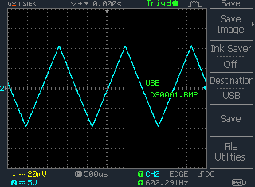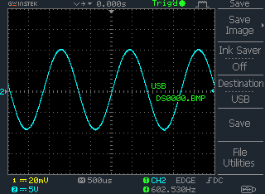

**Figure: 01** **Figure: 02**

VP = 2.00 x 5v = 10.00 v

**Sin wave** T = 1.2 x 1 µs = 1.2 µs

f = 1/T = 1/1 = 1 Hz

VP = 2.2 x 5v = 11 v

**Square Wave** T = 1.2 x 1 µs = 1.2 µs

f = 1/T = 1/1 = 1 Hz

VP = 2.2 x 5v = 11 v

**Triangular Wave** T = 1.3 x 1 µs = 1.3 µs

f = 1/T = 1/1 = 1 Hz

**Figures:**

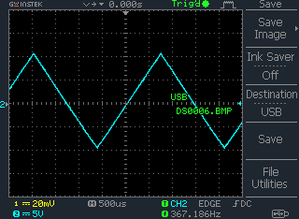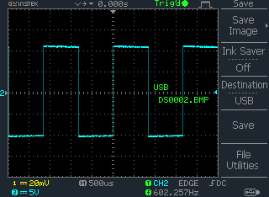

**Figure: 03** **Figure: 04**

**Report:**

We don’t find any discrepancy in out Experiment works and we have collected all the values properly.

We have completed our all calculations perfectly. We have calculated all the calculations and last we have found a reasonable values which are almost similar to our practical values.